Comp1168-Database Management-Group Project

Paxton Maxim - 101064370

Phung Jacky - 100801047

Rodney Jarone - 101077225

Santiago Charles Kenn – 101084441

Table of Contents

Conceptual Data Model

Logical Data Model

Data Dictionary

Relational Schema

Query Results

Conceptual Data Model

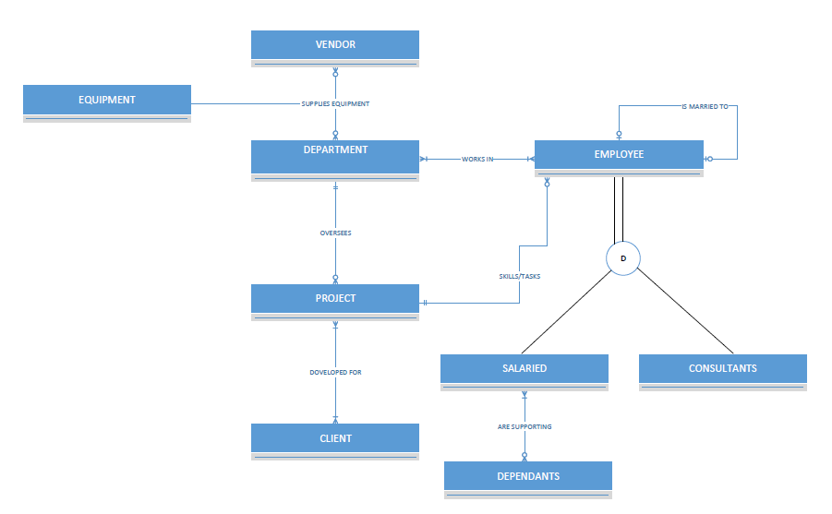

For the employee entity we can assume there could be employees who are married to each other and are in the same company. Since the married couples are in this company that also mean the health coverage they get is under one name.

Logical Data Model

VENDOR

EQUIPMENT

SHIPMENT

DEPARTMENT

EMPLOYEE

JOB_TITLE

JOB_ARCHIVE

SKILL_TASK

CLIENT

CLIENT_PROJECT

PROJECT

SALARIED

CONSULTANT

DEPENDENT

OVERSEES

WORKS IN

DOVELOPED FOR

ARE SUPPORTING

IS MARRIED TO

PK

PK

FK

PK

PK

FK

PK

FK

PK

PK

FK

PK

FK

PK

FK

PK

FK

PK

EMPLOYEE ASSIGNMENT

PROJECT ROLES

PK

FK

PK

FK

PK

PK

PK

PK

PK

Data Dictionary

Employee

|  |  |  |  |  |
| --- | --- | --- | --- | --- |
| Attributes | Attribute Date Type | Required/Optional | Example Instance | Example Instance |
| Employee ID (PK) | INT (9) | Required | 123 456 789 | 567 111 222 |
| Name | CHAR (40) | Required | Last Name, First Name | Doe, John |
| Address | CHAR (30) | Required | 167 Kendall Ave. | 100 City Centre |
| Date of Birth | CHAR (10) | Required | MM/DD/YYYY | 05/14/1990 |
| Job Title | CHAR (40) | Required | Quality Assurance | Accounting Manager |
| Skills  {C#, VB.net, SQL Server, Project Management} | CHAR (25) | Required | C#, VB.NET | Project Management, SQL Server |
| Skill Description | CHAR(40) | Required | Manages Project | Quality Assurance for C# |
| Employee Type | CHAR (20) | Required | Salaried | Consultant |
| SIN | INT (9) | Required | 111 222 333 | 444 555 888 |
| Dependent | INT(2) | Optional | 0 | 2 |

Project

|  |  |  |  |  |
| --- | --- | --- | --- | --- |
| Attributes | Attribute Data Type | Required/Optional | Example Instance | Example Instance |
| Project ID (PK) | INT (9) | Required | 123-456-789 | 005-265-325 |
| Name | CHAR (40) | Required | Protein Simulator | NCIX Point of Sale |
| Cost Estimation | DECIMAL (10) | Required | $50000.00 | $250.75 |
| Equipment | CHAR (30) | Optional | Computer, Presentation Room | Board Room, Projector |
| Tasks | CHAR (50) | Required | 2. System Analysis, 3. Coding | 7.User Training |
| SIN | INT (9) | Required | 092 520 420 | 416 416 416 |

Client

|  |  |  |  |  |
| --- | --- | --- | --- | --- |
| Attributes | Attribute Data Type | Required/Optional | Example Instance | Example  Instance |
| Client ID (PK) | INT (9) | Required | 000-300-879 | 002-564-485 |
| Client Name | CHAR (40) | Required | Last Name, First Name | McIntyre, Phillip |
| Telephone | INT (10) | Required | (416)-987-879 | (248)-249-9856 |
| Company | CHAR (40) | Required | McIntyre Inc. | Atlus Co. |
| Address | CHAR(40) | Required | 192 Bits Rd. | 6400 Oak Canyon |
| ClientSinceDate | CHAR (10) | Required | MAR/16/2008 | DEC/15/2013 |

Equipment

|  |  |  |  |  |
| --- | --- | --- | --- | --- |
| Attributes | Attribute Data  Type | Required/Optional | Example Instance | Example Instance |
| Equipment ID (PK) | CHAR (25) | Required | CHR.4345456 | DELL.INSP789 |
| Cost | DOUBLE (9) | Required | $45000.99 | $9874.75 |
| Brand | CHAR (30) | Required | DELL | Epson |

Department

|  |  |  |  |  |
| --- | --- | --- | --- | --- |
| Attributes | Attribute Data  Type | Required/Optional | Example Instance | Example Instance |
| Department ID (PK) | CHAR (25) | Required | RD300 | ACC205 |
| Telephone | CHAR (15) | Required | 416-987-546- ext.300 | 416-645-2130- ext.205 |
| Location | CHAR (30) | Required | 4-20 | 1-30 |
| Department Manager (FK)  [Employee ID] | INT (9) | Required | 055-900-879 | 654-924-598 |

Vendor

|  |  |  |  |  |
| --- | --- | --- | --- | --- |
| Attributes | Attribute Data Type | Required/Optional | Example Instance | Example Instance |
| Vendor ID (PK) | CHAR(9) | Required | SUN630914 | MET246951 |
| Name | CHAR (30) | Required | Sun Corp. | Metro Electric Ltd. |
| Address | CHAR (30) | Required | 901 Bell Rd. | 7650 Capy Blvd. |

Shipment

|  |  |  |  |  |
| --- | --- | --- | --- | --- |
| Attributes | Attribute Data Type | Required/Optional | Example Instance | Example Instance |
| Vendor ID (PK, FK) | CHAR(9) | Required | SUN630914 | MET246951 |
| Equipment ID (PK, FK) | CHAR (25) | Required | CHR.434456 | DELL.ISNP789 |
| Arrival Date | CHAR (13) | Required | JAN/24/2017.12:35 | MAR/9/2016.14:00 |
| Shipment Date | CHAR (20) | Required | SEP/12/2013.20:00 | JUL/30/2017.14:00 |

Data Relational Schema

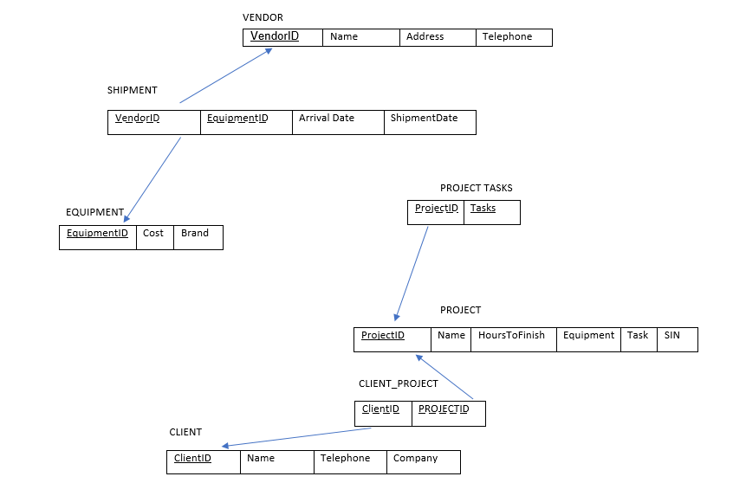

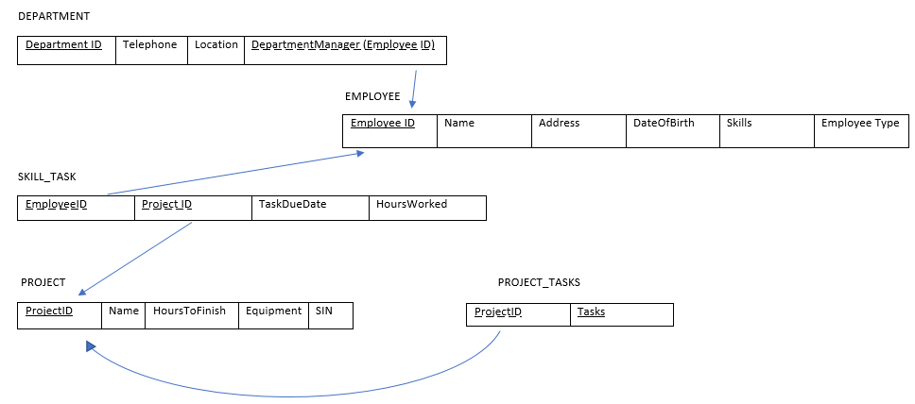

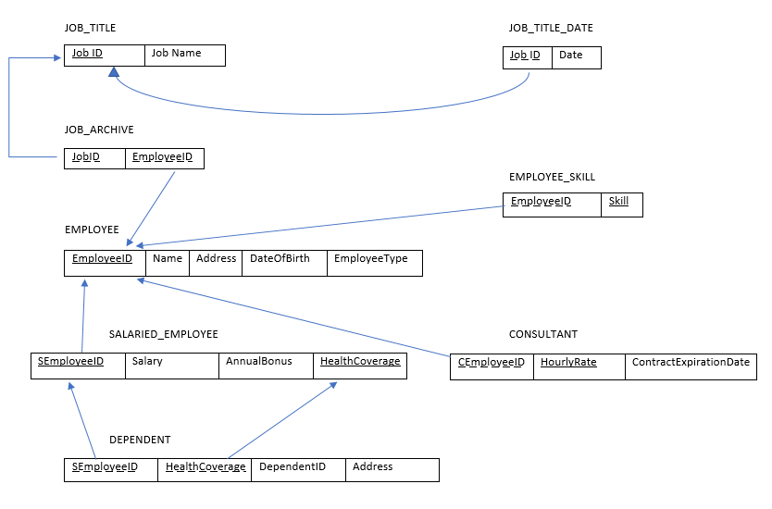

Query Results

/* 1. */

select employeeid, salary, healthcoverage, bonus

from salariedemployee_t

where bonus>10000;

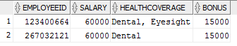

/* 2. */

SELECT p.projectid, p.projectname, sk.employeeid, sk.hoursworked, e.employeename, ja.jobid

FROM employee_t e, jobarchive_t ja, project_t p, skilltask_t sk

WHERE p.projectid = sk.projectid AND sk.employeeid = e.employeeid AND e.employeeid = ja.employeeid;

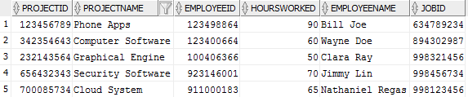

/* 3. */

select count(*) from client_t;



/* 4. */

select c.clientid, c.companyname, e.brand

from client_t c, equipment_t e

ORDER BY e.brand, c.companyname;

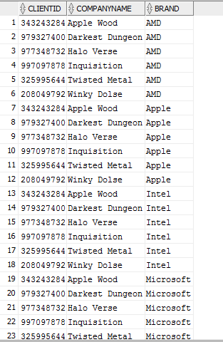

/* 5. */

select count(employeeid), salary

from salariedemployee_t

GROUP BY salary

HAVING count(employeeid)>0;

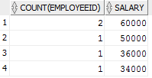

/* 6. */

CREATE OR REPLACE VIEW BRANDANDVENDOR AS

SELECT e.brand AS "Brand", e.equipmentid AS "Equipment ID", s.vendorid AS "Vendor ID"

FROM equipment_t e

INNER JOIN shipment_t s

ON s.equipmentid = e.equipmentid

INNER JOIN vendor_t v

ON s.vendorid = v.vendorid

ORDER BY e.equipmentid;

SELECT * FROM BRANDANDVENDOR;

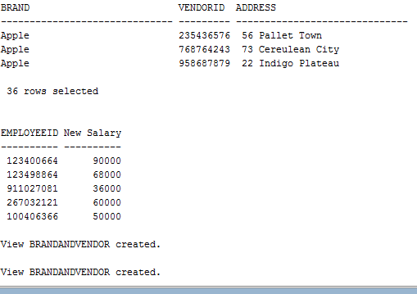

/* 7. */

select e.employeeid, e.employeename

from employee_t e

RIGHT OUTER JOIN department_t d ON d.employeeid = e.employeeid;

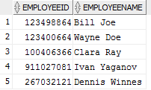

/* 8. */

select employeename

from employee_t

where employeeid in (select distinct(employeeid) from salariedemployee_t);

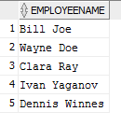

/* 9. */

select e.brand, v.vendorid, v.address

from equipment_t e, vendor_t v;

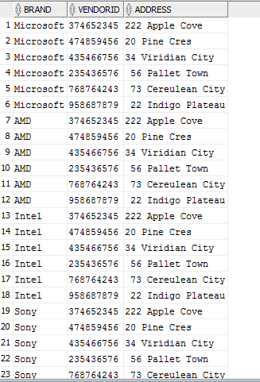

/* 10. */

select employeeid,

case employeeid

when 123400664 then salary * 1.5

when 123498864 then salary * 2

else salary

end as "New Salary"

from salariedemployee_t;

